SCOPE OF WORK

Mobile Offshore Drilling Unit (MODU)

Remainder of this Page Intentionally Left Blank

SCOPE OF WORK
Mobile Offshore Drilling Unit (MODU)

1.0 PROJECT SUMMARY 3
2.0 WORK SCOPE SUMMARY 4
3.0 ATTACHMENT 7

PROJECT SUMMARY
The main objectives of the CONTRACTOR Scope of Work, specified herein, are to support drilling operations for Fieldwood Energy E&P México, S. de R.L. de C.V.
This tender is for a Mobile Offshore Drilling Unit (MODU) required for drilling and completing wells in FEEP’s Contract Area 4, Ichalkil and/or Pokoch Fields. COMPANY plans to drill and complete three (3) development wells over a period of approximately 18 months during the remainder of year 2022 and into year 2024. Other work may include sidetracking, wellbore stimulations, workovers, and recompletions of wells previously drilled.

Definitions
For the purpose of this Scope of Work, the following words and phrases shall have the meaning stated below:

Area of Operation | Fieldwood Energy E&P Mexico’s (FEEP) areas of operations consist of offshore drilling in Contract Area 4 (Ichalkil and Pokoch Fields) located offshore Gulf of Mexico (Mexico).
COMPANY | Any Fieldwood Energy E&P Mexico (FEEP) and affiliated department requesting the services in this specification.
COMPANY Helipad | Location is Heliservicio at Ciudad del Carmen International Airport, COMPANY operated location where flights to MODU depart. CONTRACTOR delivery point for offshore personnel.
COMPANY Offices | COMPANY offices in Mexico City and Ciudad del Carmen, Mexico.
COMPANY Shore base | COMPANY operated facility in Ciudad del Carmen.
CONTRACTOR | The Organization performing the Services to which this scope of work is applied.
Mobilization/Demobilization  MOB/DEMOB | Movements of CONTRACTOR personnel in/out of Mexico. CONTRACTOR is responsible for arranging MOB/DEMOB of all CONTRACTOR personnel.  CONTRACTOR shall be compensated for MOB/DEMOB of CONTRACTOR equipment and personnel as defined in Appendix 3 – Bid Forms.
MODU | Mobile Offshore Drilling Unit (MODU) is a Jack-up drilling unit capable of shallow-water drilling operations in the Gulf of Mexico.
Point of Origin Facility | CONTRACTOR principal base of operations, where personnel are based.
Support Facility | CONTRACTOR facility/base, whether principal or satellite, that supports personnel for COMPANY operations.
Transportation | Movements of CONTRACTOR personnel within Mexico. CONTRACTOR is responsible for transportation, of all CONTRACTOR personnel. Offshore personnel delivery point is COMPANY Helipad, or if required the shore base for vessel transport.

WORK SCOPE SUMMARY
This contract is for the provision of a Mobile Offshore Drilling Unit (MODU) and associated services. COMPANY’s target spud date is in Q3 2022. COMPANY plans to drill and complete three (3) firm development wells located in the Ichalkil Field offshore Mexico with two (2) options to perform “Other” work. Other work scope may include drilling and completing additional wells (60-days’ notice), and/or perform well stimulation, workover, and/or well recompletion activities on wells previously drilled (15-days’ notice). The options may be for work in the Ichalkil or Pokoch Fields. General project information is provided below:

Firm Development Wells: | Planned Target Depths: ±6000 m TVD SS  Water Depth: 32 m  Estimated TD MW: 12.5 – 14.0 range  Estimated Well Duration: ~ 180 days (drill and complete)
MODU: (Jack-up) | TBD
Place of Work: | CONTRACTOR office(s), COMPANY office or Well Site
Target Commencement Date of Services: | 3rd Quarter 2022

Operational Area

FEEP Contract Area 4 – Ichalkil and Pokoch Fields
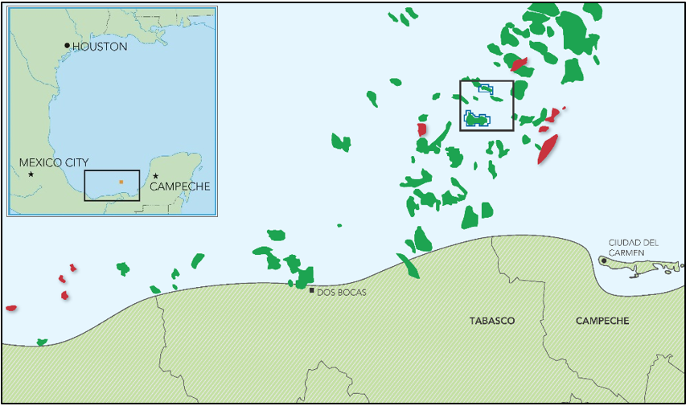
Ichalkil Field
Pokoch Field

CONTRACTOR shall provide the MODU, all applicable equipment, and the required personnel to drill and complete three (3) wells and perform other work as described above. Mobilization/Demobilization point is in Contract Area 4, Offshore Gulf of Mexico, Mexico. The table below outlines the planned and contingent casing strings, and the anticipated mud weights for a typical well. For clarity, a general well schematic is also attached (see section 5). MODU shall be capable of handling all projected loads per the well design below.

General Development Wells (Ichalkil Field) – Water Depth = 32m, RKB – ML = 85m:

Casing String | Weight | Mud Wt  PPG | Casing length (m) | Casing Depth RKB (m)
30” | 1” WT: 310 ppf | 8.6 – 8.9 | 250 | 250
20” | 133 ppf | 8.9 - 9.2 | 1050 | 1050
16”  16-1/4” | 109 ppf  122.5 ppf | 13.5 – 13.8 | 1400  800 | 2200
14” Liner  13-5/8” Tie-back | 113 ppf  88.2 ppf | 15.5 -16.0 | 2650  2050 | 4700
9-7/8” Liner  9-7/8” Tie-back | 62.8 ppf  62.8 ppf | 8.3 – 9.0 | 500  4550 | 5050
7-5/8” Liner | 39.0 ppf | 11.5 – 14.0 | 1100 | 6000
5-1/2” Liner (contingency) | 23.0 ppf | 12.5 - 14.5

General Development Wells (Pokoch Field) – Water Depth = 46.3m, RKB – ML = 86m:

Casing String | Weight | Mud Wt  PPG | Casing length (m) | Casing Depth RKB (m)
30” | 1” WT: 310 ppf | 8.6 – 8.9 | 250 | 250
20” | 133 ppf | 8.9 - 9.2 | 1050 | 1050
13-5/8” | 88.2 ppf | 12.5 -13.5 | 2500 | 2500
9-7/8” | 62.8 ppf | 14.5 – 15.5 | 4200 | 4200
7-5/8” Liner | 39.0 ppf | 11.5 – 14.0 | 650 | 4800
5-1/2” Liner | 23.0 ppf | 12.0 - 13.0 | 450 | 5050

3.0 ATTACHMENTS
Typical Ichalkil Wellbore Schematic
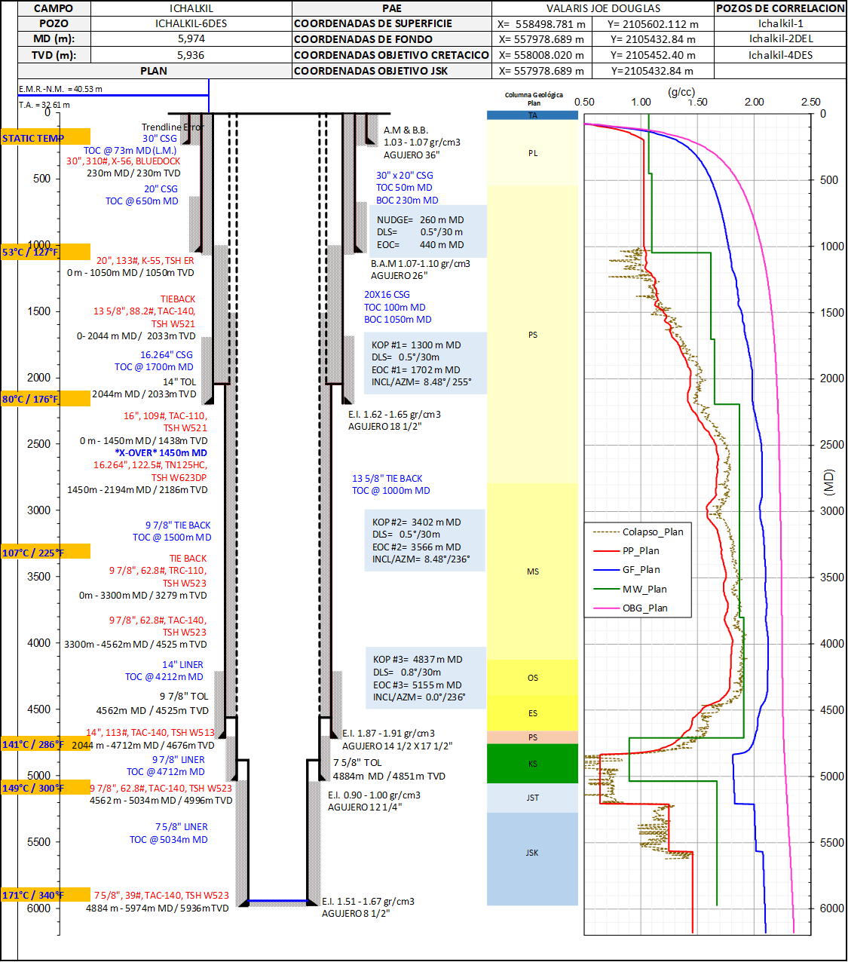

Typical Pokoch Wellbore Schematic

